Plat of Hope Cemetery
Page: 351; Book: Unknown; Date: Unknown
Surveyed by J.C. Kennedy

Description, The N.E ¼ of the S.E. qr of Sec 10 T1 S. of R1
W of the Ute Meridian. __ 40 acres.

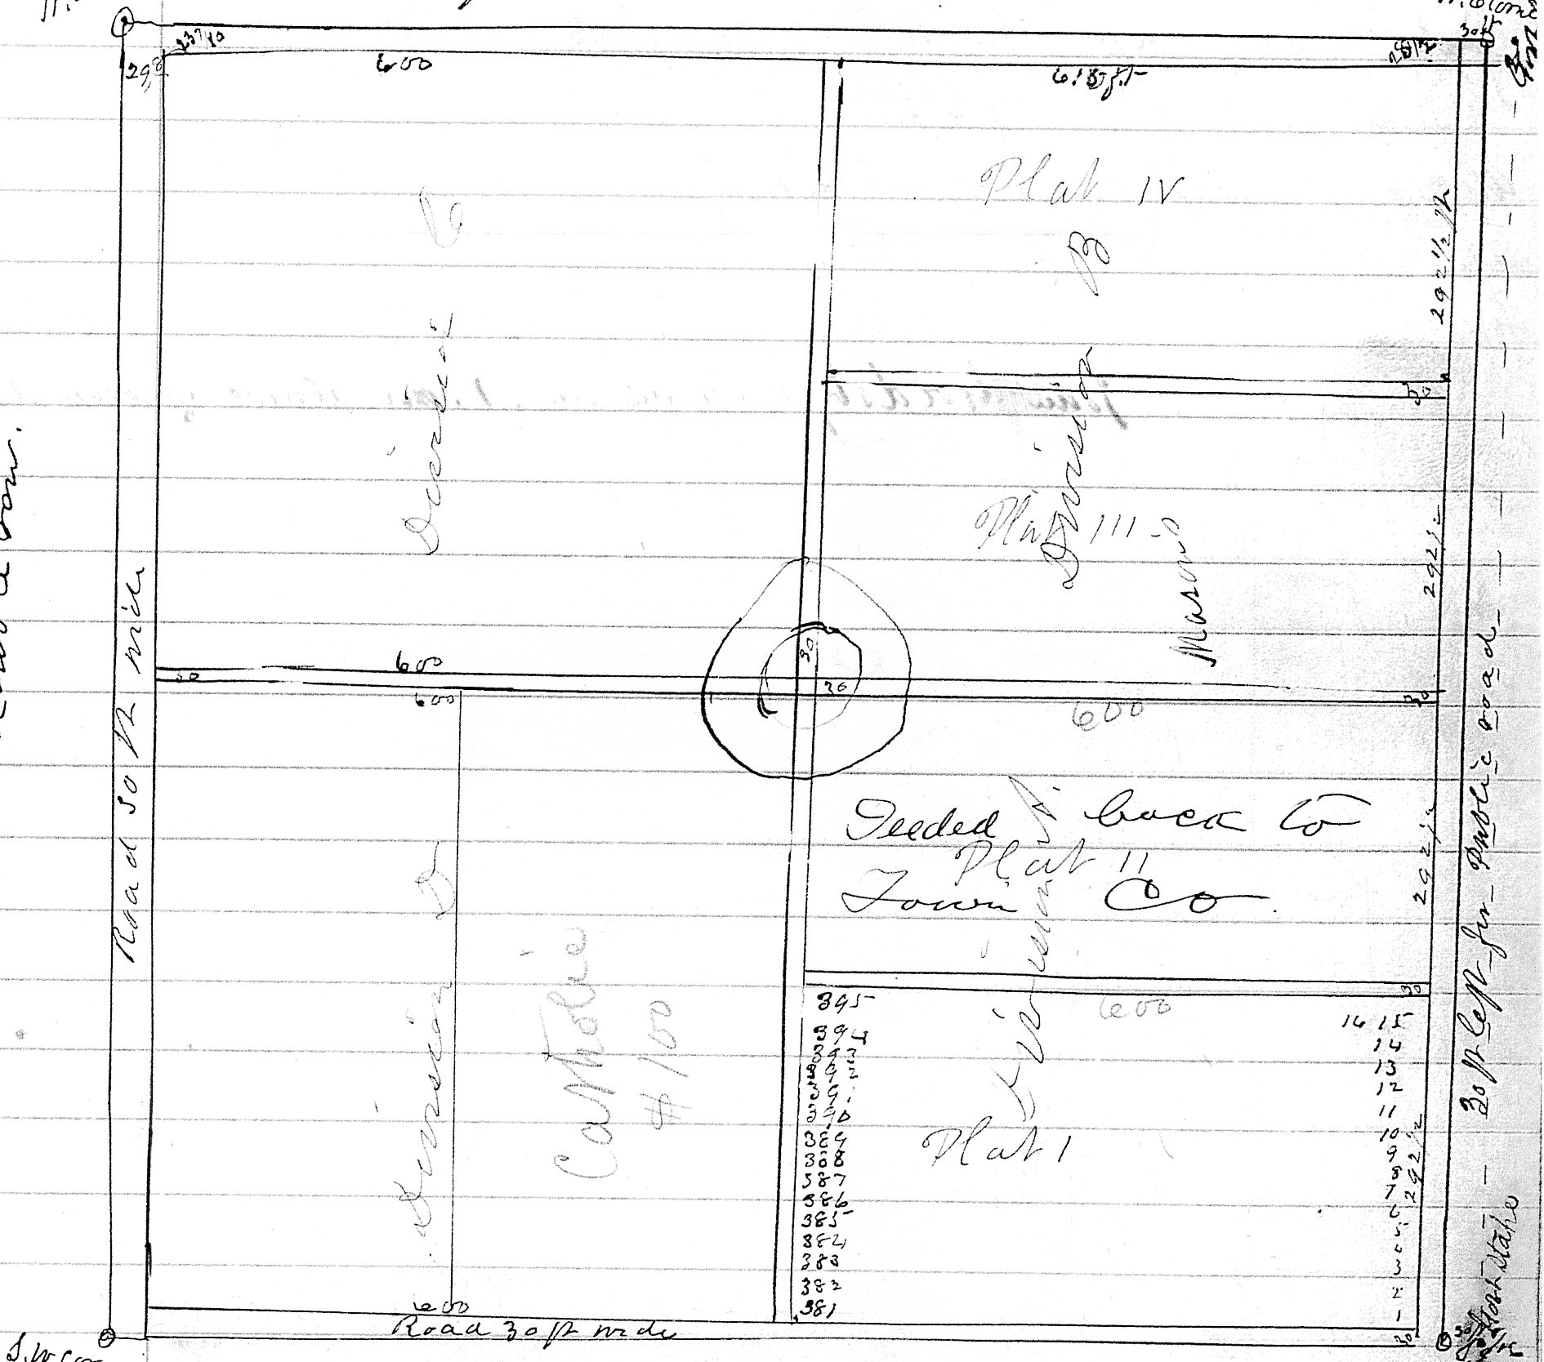 [

Written on left side of plat drawing:
Lots are 15 ft east & west by 20 ft north & south
In double rows with 15 ft alley north & east
between each double row

Ap 11. 84. Redeemed N ½ NE ¼ of SE ¼ (20 a fr tax of 87
Paid on NE ¼ of S.E. 1/4 40a fr “ of 88
“ (less 5 a cemetery “ of 89

Nov 22. 84. Warranty Deed to Mesa Lodge No 55. A.F. – A.M. for “the S ½ of N.E ¼ of E.E ¼ of S.E qr of Sec 10 (excepting; roadway 30 ft wide around the same) together with the
right of way over the roadway 30 ft wide on and around the said land, said tract
being descibed as “Plat Three”(III) of Division “B” of Hope Cemetery Grounds
and being 615 ft long east and west, and 292 ½ ft wide north and south.
the same bieng for Cemetery purposes [(*inserted in a different hand and ink, very pale) ???? as to 615 ft Kennedy mistake. Should be 600 ft ??? ??? 16.86)]
Consideration - Note of $100⁰⁰ in 1 Y with privilage of 3 - ??? payable

Transcription: Karen Merritt Sturgill 2022

